LABORATORY WORK 2
Course:Databases
Topic: Normalization & DDL (Airport Database)
Student name: Sansyzbai Aqjoltai
1.Normalization
Task 1.
Original (unnormalized) table, with one example row:
Booking_receipt
booking_id (PK) | passenger_full_name | passenger_passport_number |  | flight_num-ber |  | departure_ai-rport_name | departure_city |  |  |  | arrival_airport_name | arrival_city | airline_name | seat_numb-ers | ticket_price
1001 | Sansyzbai Aqjoltai | N1234567 |  | KC101 |  | Almaty International Airport | Almaty |  |  |  | Astana International Airport | Astana | Air Astana | 12A, 12B | 45000.00

Answer: The table violates 1NF (First Normal Form).
Reason: the column seat_numbers holds two values in one cell ("12A, 12B") because this booking covers two passengers/seats. 1NF requires every column to hold a single, atomic value — a comma-separated list is a repeating group, so the table is not atomic and is therefore not even in 1NF.
Once seat_numbers is split into one row per seat (below), a second problem appears: the natural key becomes the pair (booking_id, seat_number). Non-key attributes such as ticket_price or passenger_full_name only depend on booking_id, not on the full key — a partial dependency, which is a 2NF violation.
Finally, attributes such as departure_airport_name, arrival_city and airline_name do not depend directly on booking_id — they depend on flight_number, which itself is a non-key attribute. This is a transitive dependency (booking_id → flight_number → airline_name), which violates 3NF.

Task 2.
Step 1 — Convert to 1NF
Split seat_numbers so each row holds exactly one seat. The candidate key becomes the composite (booking_id, seat_number).
Booking_receipt
booking_id (PK) | seat_number  (PK) | passenger_full_name |  | passenger_passport_number |  | flight_num-ber | departure_ai-rport_name |  |  | departure_city |  |  | arrival_airport_name | arrival_city | airline_nam--e | ticket_price
1001 | 12A | Sansyzbai Aqjoltai |  | N1234567 |  | KC101 | Almaty International Airport |  |  | Almaty |  |  | Astana International Airport | Astana | Air Astana | 45000.00
1001 | 12B | Sansyzbai Aqjoltai |  | N1234567 |  | KC101 | Almaty International Airport |  |  | Almaty |  |  | Astana International Airport | Astana | Air Astana | 45000.00

Step 2 — Convert to 2NF
Remove partial dependencies: attributes that depend only on booking_id (not on the full composite key) move into their own table.
Booking
booking_id (PK) | passenger_full_name | passenger_passport_number |  | flight_num-ber |  | departure_ai-rport_name | departure_city |  |  |  | arrival_airport_name | arrival_city | airline_name | ticket_price
1001 | Sansyzbai Aqjoltai | N1234567 |  | KC101 |  | Almaty International Airport | Almaty |  |  |  | Astana International Airport | Astana | Air Astana | 45000.00

Booking_Seat
booking_id (PK) (FK) | seat_number (PK)
1001 | 12A
1001 | 12B

booking_id in Booking_Seat references Booking(booking_id).

Step 3 — Convert to 3NF
Remove the transitive dependency: flight-related attributes depend on flight_number, not directly on booking_id, so they move into their own Flight table.
Booking
booking_id (PK) | passenger_full_name | passenger_passport_number | flight_number (FK) | ticket_price
1001 | Sansyzbai Aqjoltai | N1234567 | KC101 | 45000.00

Booking_Seat
booking_id (PK) (FK) | seat_number (PK)
1001 | 12A
1001 | 12B

Flight
flight_number (PK) | departure_airport_name | departure_city | arrival_airport_name | arrival_city | airline_name
KC101 | Almaty International Airport | Almaty | Astana International Airport | Astana | Air Astana

flight_number in Booking references Flight(flight_number); booking_id in Booking_Seat references Booking(booking_id).

Task 3.
- booking_id → passenger_full_name, passenger_passport_number, flight_number, ticket_price
- (booking_id, seat_number) → booking_id, seat_number (trivial — composite primary key of Booking_Seat)
- flight_number → departure_airport_name, departure_city, arrival_airport_name, arrival_city, airline_name

Task 4.
Current primary key: flight_id.
Functional dependencies in Flights:
- flight_id → sch_departure_time, sch_arrival_time, departing_airport_id, arriving_airport_id, departing_gate, arriving_gate, airline_id, act_departure_time, act_arrival_time, created_at, updated_at
Answer: Yes, the Flights table is in 3NF.
Explanation: departing_airport_id, arriving_airport_id and airline_id are foreign keys, but the table stores only the IDs — not derived attributes such as the airport name or airline name. Because no non-key attribute in Flights depends on another non-key attribute (every attribute depends directly and only on flight_id), there is no transitive dependency inside this table. If the table also stored, for example, an airline_name column, that would create a transitive dependency (flight_id → airline_id → airline_name) and break 3NF — but that is not the case here.

Task 5.
This uses the same three tables designed in Task 2 (Booking, Booking_Seat, Flight), now with full CREATE TABLE / INSERT statements and 5+ rows.

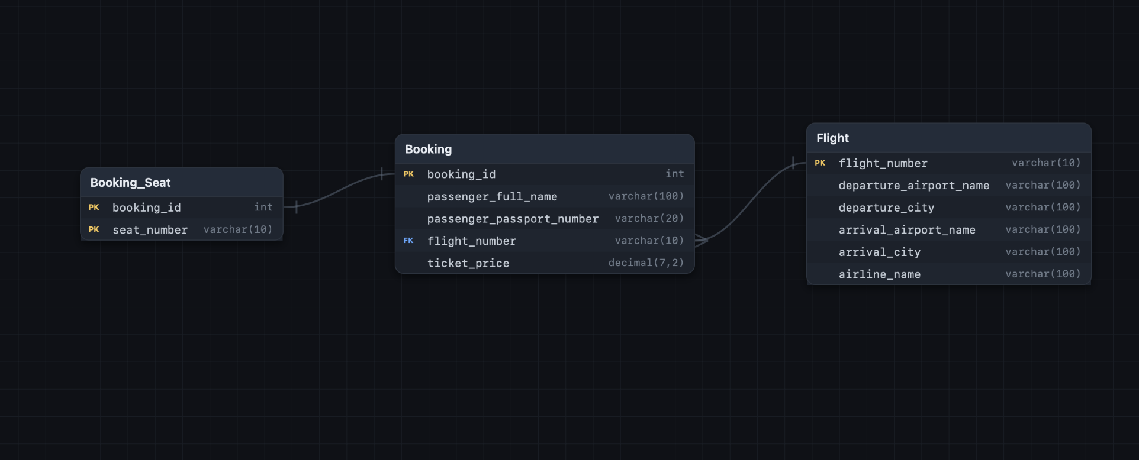

2. DDL (Airport Database)
